Community Led Temporary Shelter Construction in old towns
Background
On 25th of April, 2015 at around 11:56 in the afternoon, an earthquake of 7.8 Richter scale rocked the Nepal causing massive destruction in the country. More than 8000 people have died so far and more than 60000 people are injured. Millions of people are left homeless as more than 200000 houses are destroyed and many more not suitable for living anymore. The Kathmandu Valley is among the worst hit being close to the epicenter. The death tolls in the densely populated urban areas are extremely high and extremely affected are the old towns in periphery of the Kathmandu Valley. Majority of the house constructed with mud and timber have completely collapsed and many are no habitable. With afternoon aftershock on 12 May, many more were damaged rendering thousands more homeless and without shelter. They have lost their home, their belongings, lost their families. When the things were slowly settling in and people getting back to daily activities, the aftershock shook people’s confidence. Even the people who do not lost their houses, stayed outside homes under the plastic sheets as there are strong aftershocks going on, and nobody dare to go inside. People are still staying in tents, schools and other open spaces. With the coming monsoon, things are bound to get worst.
Even in this adverse situation, communities are rising over their pain and sadness and are supporting each other to rebuild their homes and lives. Lumanti had been working with women led saving credit cooperatives through various community empowerment and small scale infrastructure development projects. The women groups have been playing a key role in these projects and processes. These groups are linked together as network and has begun the relief support to the fellow affected communities Many of the women members were themselves have been rendered homeless in the earthquake. However, they have shown great resilience and have come forward to support the families in need. Together with Lumanti, the groups in Thaiba, Machhegoan, Sanogoan, Thankot, Khokhona, Thecho, Tokha, Panga, Gokrana, Bhaktapur, Patan Core area, Sankhu, Jeevanpur supported the affected families.
The groups were able to very quickly take a lead role in coordinating and supporting the emergency relief work in their communities: searching for survivors in the rubble, surveying the affected families and identifying priority needs, using their own funds from their collective savings to quickly purchase and distribute relief supplies, medicines and food, helping set up temporary shelters and community kitchens for newly homeless families, coordinating with Buddhist temples and local government officials to distribute aid and lobby for needed assistance. During the first few weeks Lumanti had been supporting these community-based efforts as much as possible. What is admirable about these community women is that even though they themselves have lost their homes, some even their family members, they are working relentlessly to support their fellow community members.

Temporary Shelter Assistance
With monsoon arriving soon, families really need a roof over their head to protect their families and their belongings. Meetings with the groups and the preliminary need assessment conducted by the cooperative showed that the immediate need of the community members is the temporary shelter. Lumanti Support Group for Shelter has been closely working with the community cooperatives to support the communities in Sanogaon, Thaiba, Thecho, Khokhona, Machhegoan, Panga, Thankot, Tokha and planning to expand to new areas such as Bhaktapur, Sankhu, Gokarna where many poor families. Following process was adopted to make the access to temporary shelters to the affected families.
- Meeting among the board members, among whom some affected families sat together and decided on criteria for selecting the families. Though many families have been affected, not all the families need support. To make the process simpler and avoid conflicts in the community, they agreed on a set of criteria for selecting the families. Some of them are as follows.
- Who have lost their homes and belongings and are extremely poor.
- Women headed families who have lost their husbands during the earthquake.
- Families with many young children, pregnant women or with small babies.
- Families with old people and people with illness.
- They did an assessment of the situation of the families affected and for the first lot selected 20 families.
- The list was also shared with the community members and also the local government authorities.
- A simple 10’X12’ design using CGI sheets and bamboo was prepared by the technical team of Lumanti and a brief orientation was given to the families and the cooperative leaders. But this was not to be used as a prototype but to be used as starting point for the shelter.
- The materials need for the shelter was purchased by the cooperative in a bulk. The families had the flexibility to use whatever material is available for completing the shelter which will be their homes for at least next one year. Many families are using salvaged materials for the purpose.
- Architects, Urban Planners who had volunteered for Lumanti in other projects have supported the communities in various areas to construct shelters for these families. Together with the family members and the other community members, they are able to complete planned shelter within a very short time.
- Many families have already shifted to their new home and are looking forward to a better future.
- Several organizations such as IOM, UN Habitat, Clean Up Nepal, OXFAX etc have pledged to support our process.

Working Areas:
Lumanti is currently working in 8 different small towns in Valley but plans to expand the shelter support program to other area and beyond Kathmandu Valley. We have provided assistance to affected families in Thankot, Khokhona, Thecho, Sanogoan, Machhegoan, Thaiba, Tokha and Panga. The process will be expanded to Sankhu, Bhaktapur, Core Kathandu Area and Jeevenpur which is outside of the valley.
The list of the shelter completed so far are as follows:
Serial Number | Community | Planned Shelter | Completed So far
1 | Thankot | 50 | 23
2 | Khokhona | 50 | 13
3 | Thecho | 50 | 14
4. | Machhegoan | 60 | 55
5 | Sanogoan | 50 | 6
6 | Thaiba | 50 | 35
7 | Tokha | 30 | 4
8 | Panga | 30 | 10
9 | Gokrana | 20
10 | Bhaktapur | 50
11. | Sankhu | 20
12 | Jeevanpur | 200
 | Total | 660 | 160

Glimpses of Temporary Shelter construction process in different area:
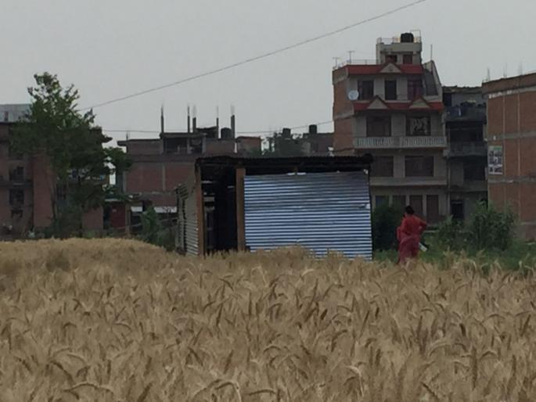 Thecho
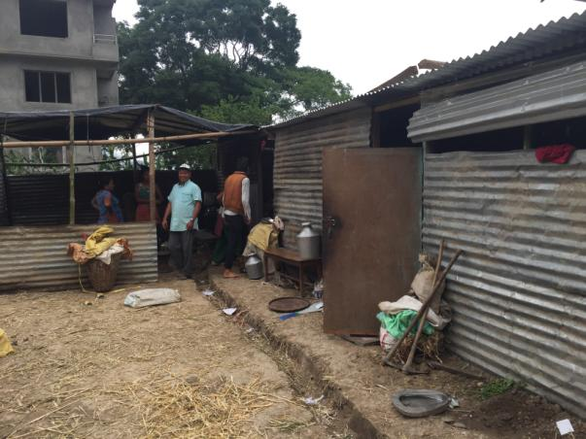 Machhegoan
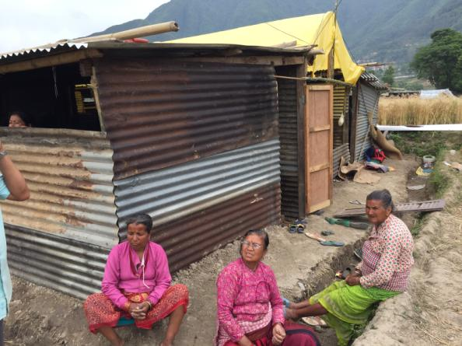 Machhegoan
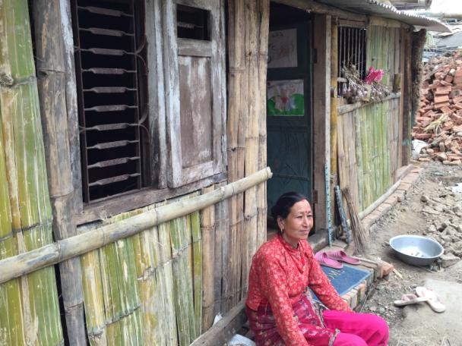 Machhegoan
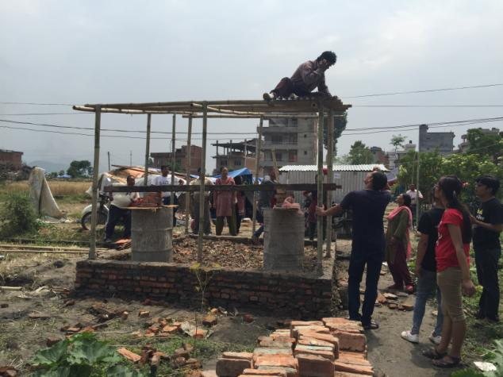 Sanogoan
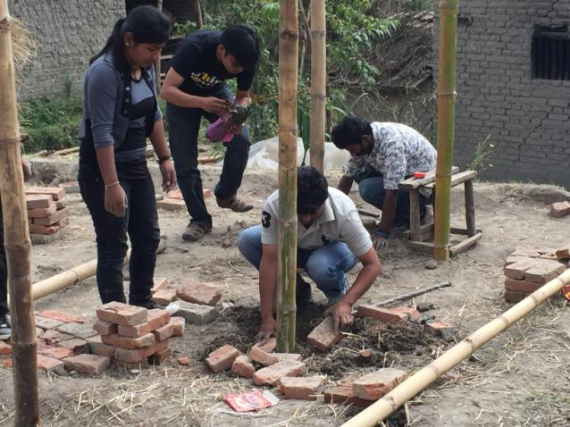
PTAG Volunteers supporting families to build the shelter in Tokha.

Note;
This is tentative cost for temporary shelter that already discuss and consult with community people the cost is around 20,000 Nrp. But it is up to the distant and transportation cost for the time being we can approximate one temporary house is cost 25,000 Nrp.[ 8,200 Bath/245 USD]

Tentative estimated cost (NRs) and material required for one unit of temporary shelter

Corrugated Sheets = 10,000
Bamboo = 1,000
Vehicle (to transfer materials ) = 3,000
Wage for workers = 6,400 [(600 + 1000) * 6 days]
Total Cost = 20,400 (20,000 per house)

