Perween Rahman Fellowship Program 2015

Perween Rahman was an architect, social scientist and planner who for many years directed the work of the Orangi Pilot Project (OPP) in Karachi, Pakistan. Through the delicate interventions and technical guidance of the OPP, Perween was able to help informal communities across Karachi - and Pakistan - develop simple, practical and affordable ways to access sanitation, water supply, housing improvements, education, health care and secure land tenure, in which communities themselves are the key doers and professionals are their supporters.
It is believed that this brave woman stepped on powerful toes while documenting informal settlements and the illegal water-supply business in the city, for on March 13, 2013, at 7:00 PM, she was killed on her way home from work.
Perween was one of the founder members of ACHR in 1989. But even though so many of us have learned from and been inspired by the work of this busy and committed woman, Perween very seldom agreed to leave her work in Karachi to join our gatherings. But on one of those rare occasions, in January 2011, she offered us these wise words:
"The situation in Pakistan is indeed very tough - the Taliban, the bombs, the violence, the disasters. Yet everywhere we look, there are signs of hope. And we need to see these signs of hope with eyes of respect, to support them, to link them, to make them strong, and to see what new can be done."

WHY THE FELLOWSHIP?
Since Perween's death in March 2013, her colleagues in Pakistan have begun projects to commemorate Perween's work in several ways. The Perween Rahman fellowship is a way her friends in the ACHR network mean to keep alive the extraordinary spirit and innovation of her work. Perween was above all a consummate community architect, and the fellowship is being launched to nurture a new generation of community architects to follow her example of working closely with poor communities, as equals, and of merging the professional with the people, to create a new kind of community planning and construction process that makes big change in the lives of the poor.

WHAT DOES THE FELLOWSHIP OFFER?
The fellowship offers a small grant of $2,000 to work with communities in an active process of change - and to learn a lot in the process. You will not be alone: the fellowships will be embedded in the work of ACHR, which links community groups, NGOs and support professionals in 20 Asian countries around a process of citywide and people-driven slum upgrading, in which the poor are the key doers in finding creative solutions to their problems of land, housing and services. You will also be part of the Community Architects Network (CAN), which has become an important technical support system for this people-driven change process in Asia.

WHO CAN APPLY?
Each fellowship is for one person, who could be an architect, planner or engineer, or a community-based builder or technician. A group can propose a fellow they'd like to work with, or you can propose yourself. Applicantmust get the agreement of the community or network of communities you'd like to work with, or of the local support organization you will link with.

WHAT CAN YOU DO?
The work you propose to do should last at least 6 months, should be based in action (not research), and should bring benefit to the community (or communities) you work with. The proposed work should have a clear context - a certain city, or a certain community or network of communities, or a certain housing project - and should build on some kind of relationship or program which has already begun (with a local support organization or community network, for example).

HOW MUCH IS THE FELLOWSHIP GRANT?
Each fellowship offers US$2,000, to partly support a person to work with poor communities on the ground for at least 6 months, on various kinds of initiatives, such as housing and settlement planning and design, community mapping, alternative and low-cost construction techniques. The budget is quite small, so it's important that each fellow finds ways to contribute and to make big change with small funds - which was a guiding principal of Perween's work and is a key part of ACHR's working philosophy also.

HOW TO APPLY?
The first round of fellowship proposals will be selected by PRF committees. After a month of screening, the first set of fellowships will be announced. All the proposals will first be screened by a core team from CAN and ACHR, then sent to the key groups in the host countries to check and comment on, and finally reviewed and agreed upon by a senior regional committee.

FELLOWSHIP BUDGET :
The Perween Rahman Fellowship Fund will start with a capital of $30,000, drawn from the Rockefeller Foundation's institutional grant to ACHR. This means that initially, we will be able to support 15 fellows.

HOW DOES THE PROGRAM LINK WITH CAN/ACHR and REGIONAL NETWORK? :
Through the process of the fellow’s selection and working, all fellow will be introduced to CAN group
and ACHR’s coalition in the country where they are working as their mentor or advisor. The fellows will be invited to be part of CAN team to work on community projects or contribute to the regional CAN
workshop. All lessons learnt, impacts, and working methods from the project will be recorded into a
handbook for sharing this collective learning to young architects and practitioners around Asia.
Note – For 10 out of 15 fellowships this year, we will give priority to proposals that support the Regional Decent Poor Program

IMPORTANT DATE/MONTH :
23rd FEBUARY : Open for application
30th MARCH : Close for application
1st APRIL - 15th APRIL : 1st round of selection by PRF committee from CAN/ACHR
15th APRIL – 30th APRIL : Final selection from key groups in the host countries
1st MAY : Annouching the fellow of 2015

Perween Rahman Fellows 2014
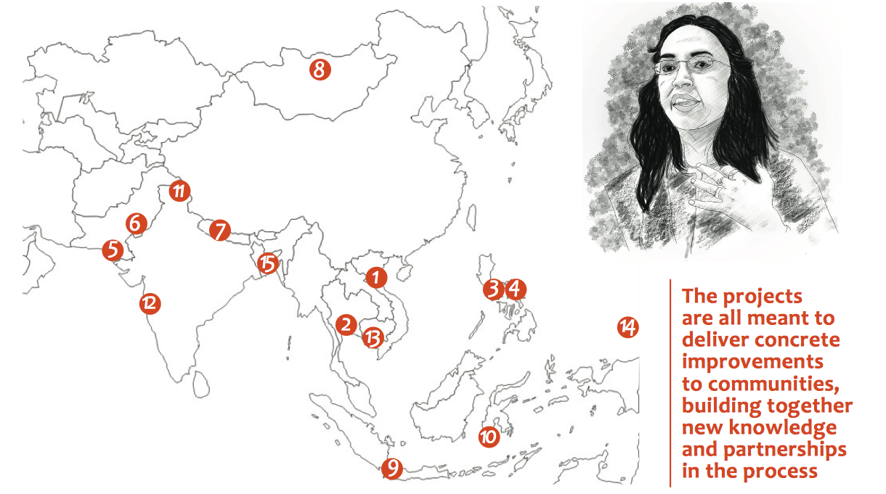
1. Bac Kan city, Vietnam / Housing Improvement - Mr. Le Nhu Nga, a young community architect worked together with community builders on a low cost housing design in Bac Kan. The design is a part of settlement upgrading involving ACVN and members of CDF at the town level.
2. Bangkok, Thailand / Comprehensive Community-Led Masterplan in Nagloeng - Architects from Openspace, together with community-based art collective E-Lerng, worked on a masterplan with the historical community of Nanglerng, that will be soon affected by the construction of a new metro station.
3. Valenzuela, Philippines / Onsite Reblocking - Ms. Villa Mae Libutaque (“Val”), an architect working with TAMPEI worked in collaboration with the Homeless People’s Federation, SHFC and FDUP worked with the ULHOA in community in Valenzuela to develop re-blocking plans and housing designs engaging with the local university.
4. Valenzuela, Philippines / Onsite Incremental housing on water - Ms. Emelyn Bermundo (“Emmy”), another TAMPEI architect, worked with university student, HPFP, and FDUP with the Del Rosario community to develop alternative plan using stilt-house design for the community, which sits on water.
5. Karachi, Pakistan / Training of community architect/ youth to work with the poor - Mr. Siraj Uddin, a community-based technician from TTRC, trained community teenagers in Baldia Town (Karachi) to conduct mapping and surveying of infrastructure services across their settlements, in collaboration with OPP and URC, to produce a city wide infrastructure services map.
6. Bahawalpur, Pakistan / Improvement of basic services (action research) - Mr. Muhammad Fiza, from HAMET, worked with a local government team in water and sanitation departments and community members to create a baseline study and cost-estimate needed to upgrade existing water supply and lane sewers in collaboration with OPP.
7. Ratnanagar, Nepal / Community re-planning for land security negotiation - Mr. Parvesh Khanal and Mr. Tulsi Kumar Kaway, Community Architects from PTAG, worked with the Salghari forest community to prepare housing and settlement upgrading plans and train local builders to negotiate for an alternative site plan in ACCA PMC.
8. Ulanbataar, Mongolia / Creating open space and green area in Ger area - Mr. Batdorj, from the Young Architects Group, worked with informal communities in Ulaanbaatar’s Sukhbaatar District to create open spaces and green areas, in collaboration with the NGO UDRC.
9. Jakarta, Indonesia / City-wide mapping to network community along Ciliwung river - Ms. Ivana Lee, an architect from Ciliwung Merdeka, worked with four informal communities along the Ciliwung river edge. She took advantage of cultural events to spontaneously involve people in participatory mapping.
10. Makassar, Indonesia / Mapping and gathering information of Kampung - Ms. Liza Marzaman, a young architect, worked with the Kampung Buloa fishing community in Makassar to map their settlement in response to new master plan by Tallo District, to develop long term upgrading plans in collaboration with the local university and ARKOM.
11. Leh, India / Community based restoration of an old shrine and temple in Ladakh - Mr. Stanzin Tundup, from the Leh Old Town Initiative (LOTI), supported a community-based project to restore an old shrine and temple in Leh, with Sumar and Chumathnag communities providing all the material and labor, in collaboration with Tibet Heritage Fund.
12. Mumbai, India / Participatory design with community school to improve school and community to be long life learning environments - Ms. Nicola Antaki worked with poor children in Muktangan (Lovegrove) school, will use the school as a laboratory to experiment with participatory design and planning prototypes, to improve the quality- of-life in their school, later their own community.
13. Phnom Penh, Cambodia / Assist in housing design of ACCA program in 3 provinces - Ms. Kao Danak, a young community architect of CAN-Cambodia, assisted communities in Kandal, Preah Sihanouk and Posenchey districts to map their settlements and develop low-cost housing design, cost estimation, and upgrading plans networking with university modules, to be partly funded by ACCA.
14. Nasinu, Fiji / Assist community by conducting reblocking workshop - Mr. Hanisetoka Manueli, a community architect, conducted reblocking design workshops with informal communities in the settlement of Caubati in the town of Nasinu, to train the communities in mapping their settlements and develop reblocking plans, in collaboration with the People’s Community Network (PCN).
15. Comilla, Bangladesh / Housing design community workshop - Ms. Fatema Sharmin Sonia, an architect, conducted participatory mapping and housing design workshops with the people in Shondip Colony, in Chittagong, to map their settlements, develop housing improvement plans and construct some pilot house designs, in collaboration with UPPR.

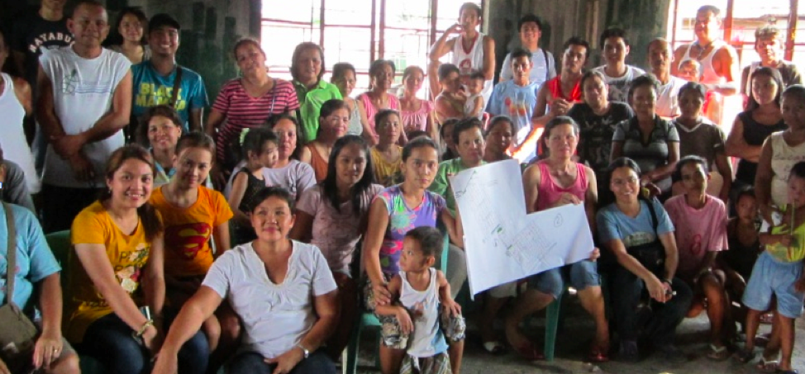
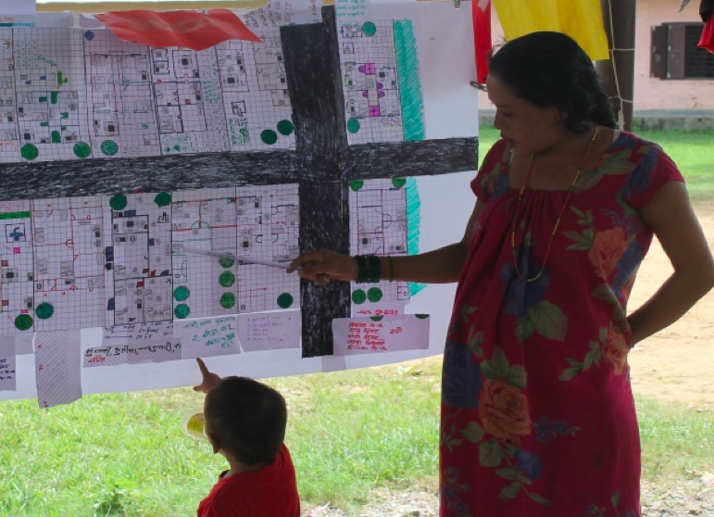

CONTACT :
For more information about the Perween Rahman Fellowship, please contact Tee at this special e-mail address: perweenrahmanfellowship@hotmail.com

To download the 2-page fellowship application form, please go to: www.communityarchitectsnetwork.info/getinvolved

